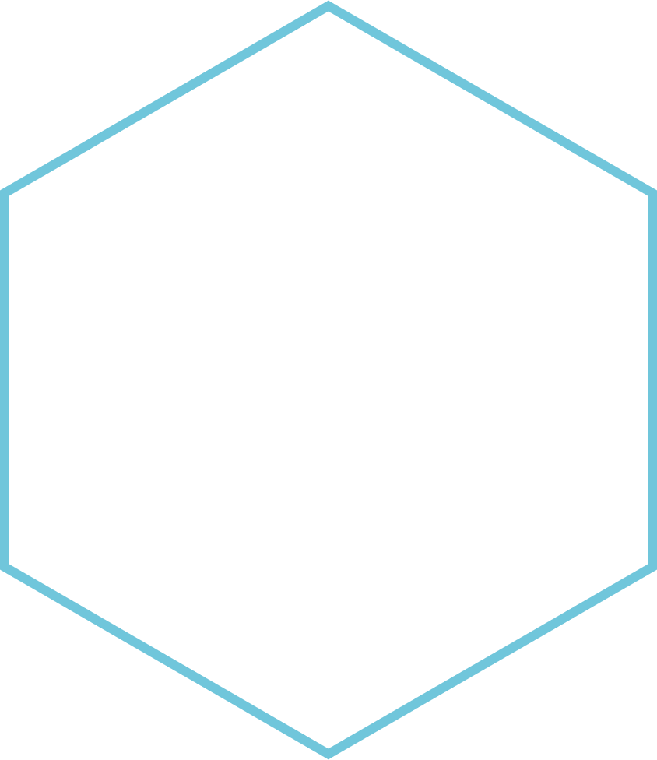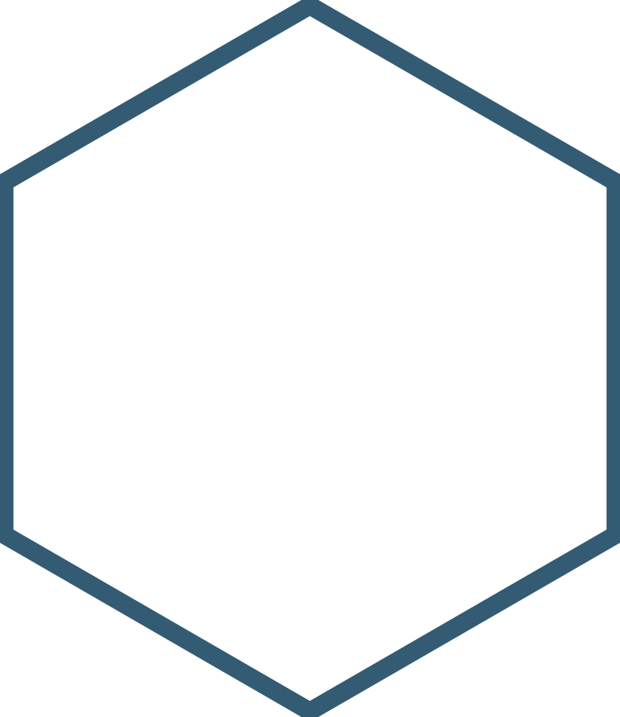

|  |
| --- |
| **IFB299 Personal Portfolio 2** |
| Kirsten Moylan – n9948210 |
| Group Number: 92  Github: Taylorbindon/IFB299 |
|  |





Contents

**Artefact 1**: Meeting with Client to show current webpages and discuss any changes. 2

**Artefact 2**: Creating multiple HTML and CSS pages following the client’s new design 4

**Artefact 3**: Creating queries for search functionality for Customer and Vehicle Pages 6

**Artefact 4**: Burn Down Chart 9

**Artefact 5**: Testing the finalized website to make sure each feature works before showing client final product 10

# **Artefact 1**: Meeting with Client to show current webpages and discuss any changes.

When undergoing a project, it is very important to have continuous meetings with the client to ensure the overall product is to the client’s standards, and up to date. As it is a well-known that during a project many changes will occur these could be to the design, the software, the layout or even the security.

In our case we did do regular meetings between us (the developers) and the clients to ensure that the client was happy, with the progress made and to ensure that nothing in relation to design and functionality had been changed. This was very useful as on the 21st of September a meeting was called by the client to update us on some changes that needed to occur on some pages of the website. Please refer below (figure 1) for screen captures of information taken away from the meeting, along with a side by side of the old webpages and the new UI design created by the client.

This information is a significant contribution to the project as, if meetings were not done with the client then we (the developers) are at risk of not meeting the needs of the client, which could lead to termination of our contract, or restarting the project. Along with this the group meetings are good to maintain a good relationship with the clients and allows both the clients and the developers to jump ideas off each other.

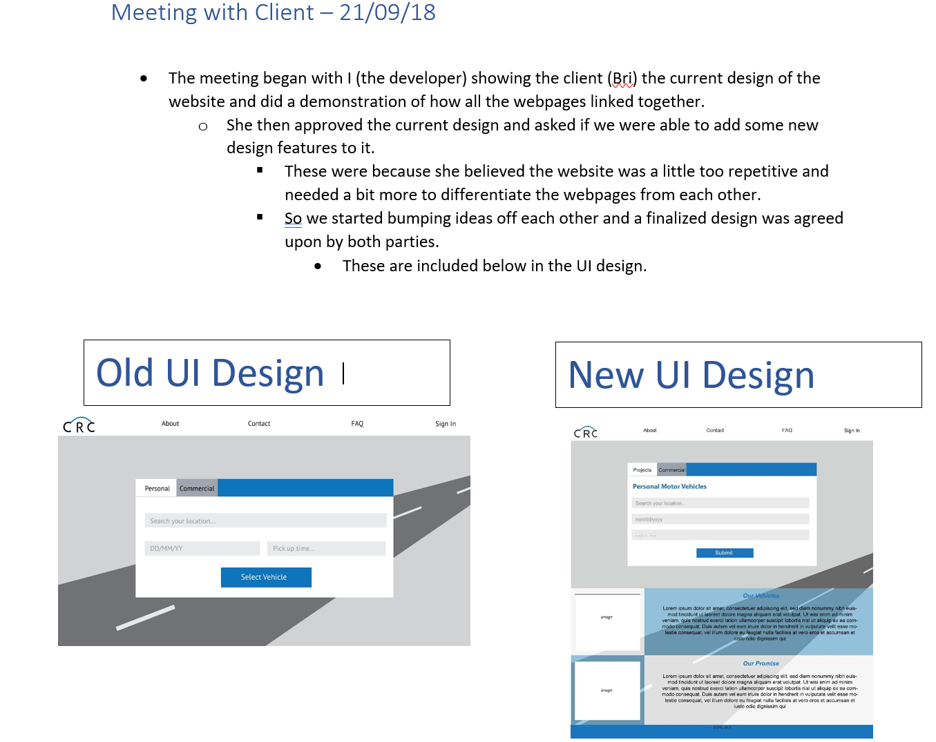

**Figure 1: Notes taken from meeting with client**

***Please note:*** *In relation to Artefact 1 please refer to the Github to see the comparison of all old vs new UI designs. This is labelled in the Githubs as ‘21-09-18 Meeting with client’.*

(Github/IFB299/Final Release/[Artefact 1 - Meeting with Client](https://github.com/taylorbindon/IFB299/commit/b37dfa3ead413b8eee4ae466de3f99c8033a9439))

# **Artefact 2**: Creating multiple HTML and CSS pages following the client’s new design

HTML (Hypertext Markup Language) and CSS (Cascading Style sheet) are the two main coding languages used to create websites and webpages. These two languages follow a similar layout and are often used side by side. This is done in the sense that a single CSS document is created with all the design elements that each webpage in a website (written in HTML) should follow. CSS and HTML often interlock with each other as CSS gives HTML identical design on each webpage, to maintain consistency.

This was used significantly throughout the project as this is one of the main parts of the project in the sense that this is the UI (user interface) and the clients and employees of CRC will be using this every day. This artefact included updating 2 of the 11 webpages to ensure they met the clients new design. However, also involved creating 7 other pages from scratch, based on the client’s new designs. The final 2 pages (that had already been previously made) were updated by two other team members (Brianna and Wenona), which also in complied with the client’s needs.

I believe this was a significant contribution to this project as this will be what the client is presented with at the end of the project and then if they are happy with it implement it into their own organization, to be used by their employees and customers.

**Please note:** For this artefact the code was written in HTML, due to it being created prior to the implementation of the various python Django pages.

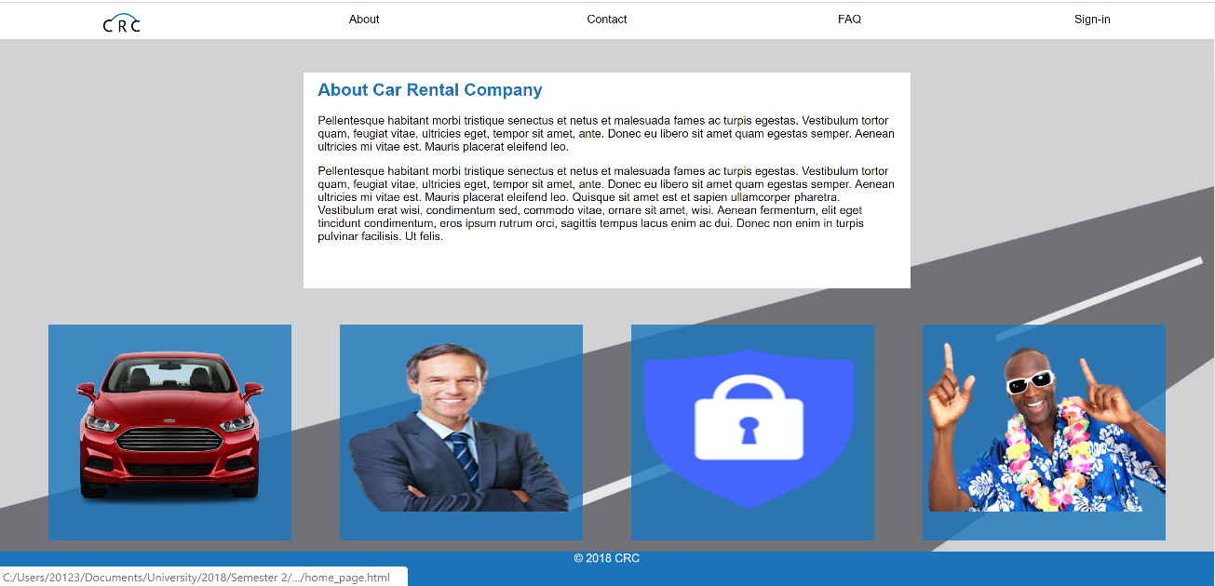

**Figure 1: Output of 1 HTML page (About.html)**

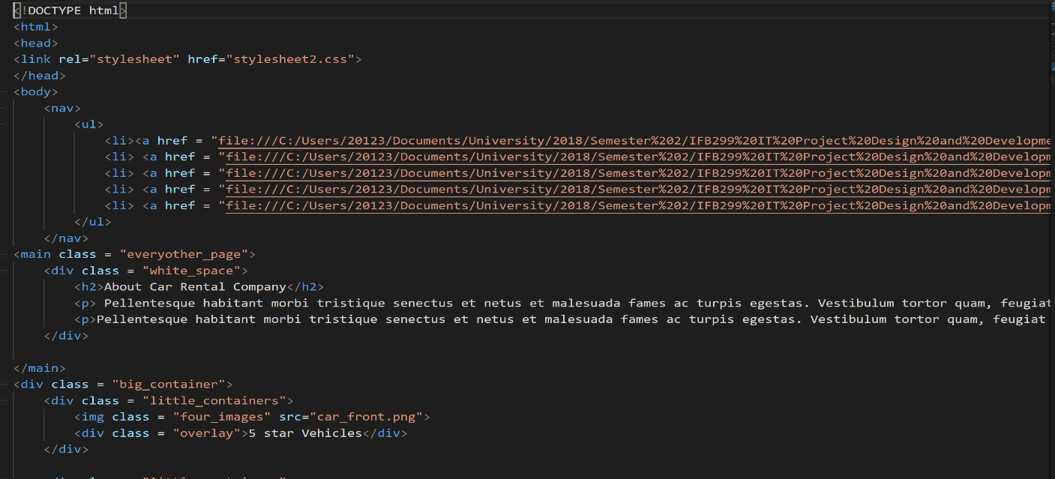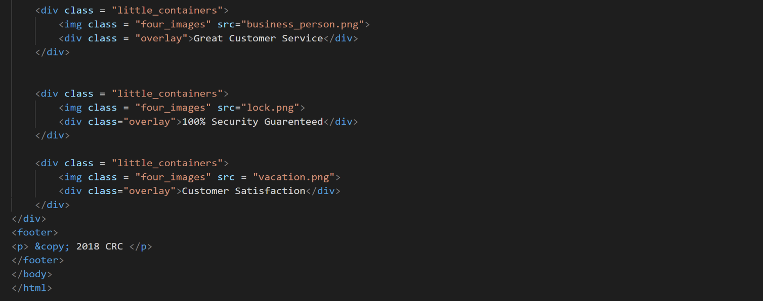

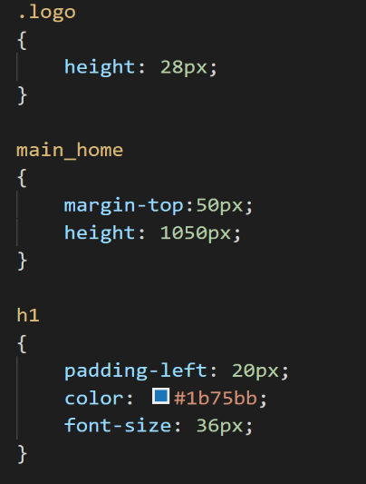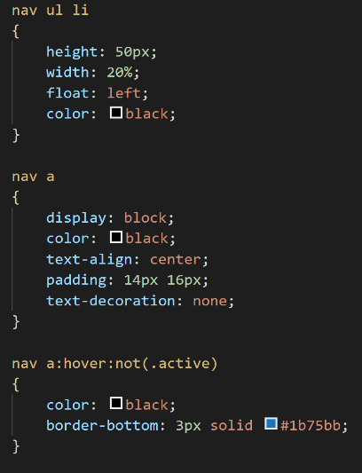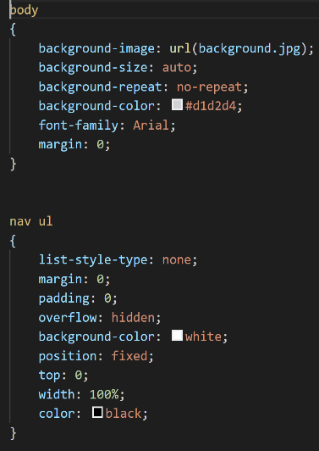**Figure 2: HTML Code (for About page)**

**Figure 3: Part of CSS Code**

**Please Note:** In relation to Artefact 2 please go to the groups Github to see all other HTML Webpages and the finished whole CSS document. (Github/IFB299/Document/Webpages)

# **Artefact 3**: Creating queries for search functionality for Customer and Vehicle Pages

Queries are very important in the project, as they help the HTML page to have actual functionality. In this case I worked on the specific query of the search functionality in the employee homepage in relation to vehicles. However, a key note in this is that I did the first iteration of the query, due to my laptop having some technical issues preventing me from being able to access the database and therefore not allowing me to check for errors/debug. So, one of my team members (TJ) was able to access the database through his laptop and change my code to work correctly. however, he did this for the search function of customers within the employee homepage. So when TJ was able to get the code working for his search function (customers), I was then able to implement his code to an extent to allow for vehicle search.

Queries are very important for this project as the client and their employees will use the overall product daily. So, the inclusion of queries allows for a more functional website, that allows ease of searching the database for certain data. I believe this was a significant contribution to the project as without this query employees of CRC would be unable search for vehicles in their database, unless they went through the actual database and went through every line of code. Which would be a significantly more complicated for employees to access especially since the database could contain sensitive/confidential data.

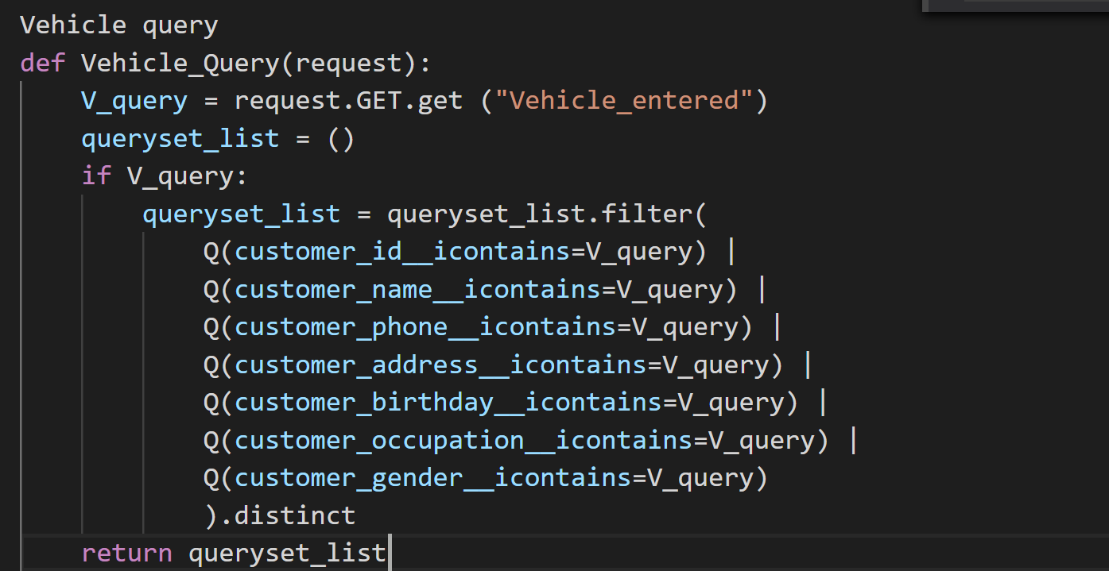

**Figure 1: 1st Iteration of Search functionality Code.**

***Please Note:***This 1st iteration of the search functionality code is not included on the Github due to TJ implementing my code, then updating it to where it is now.

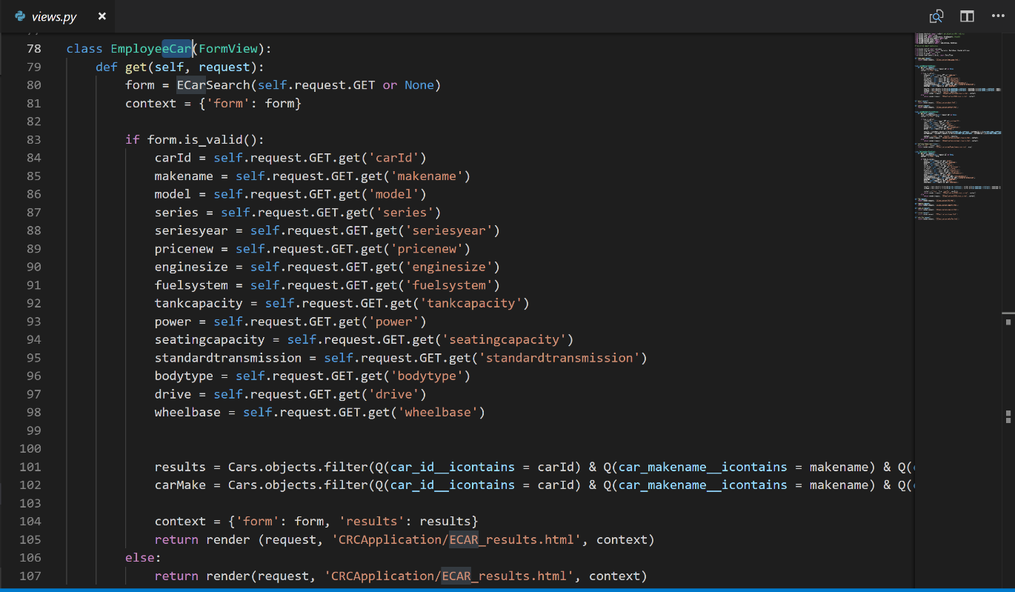

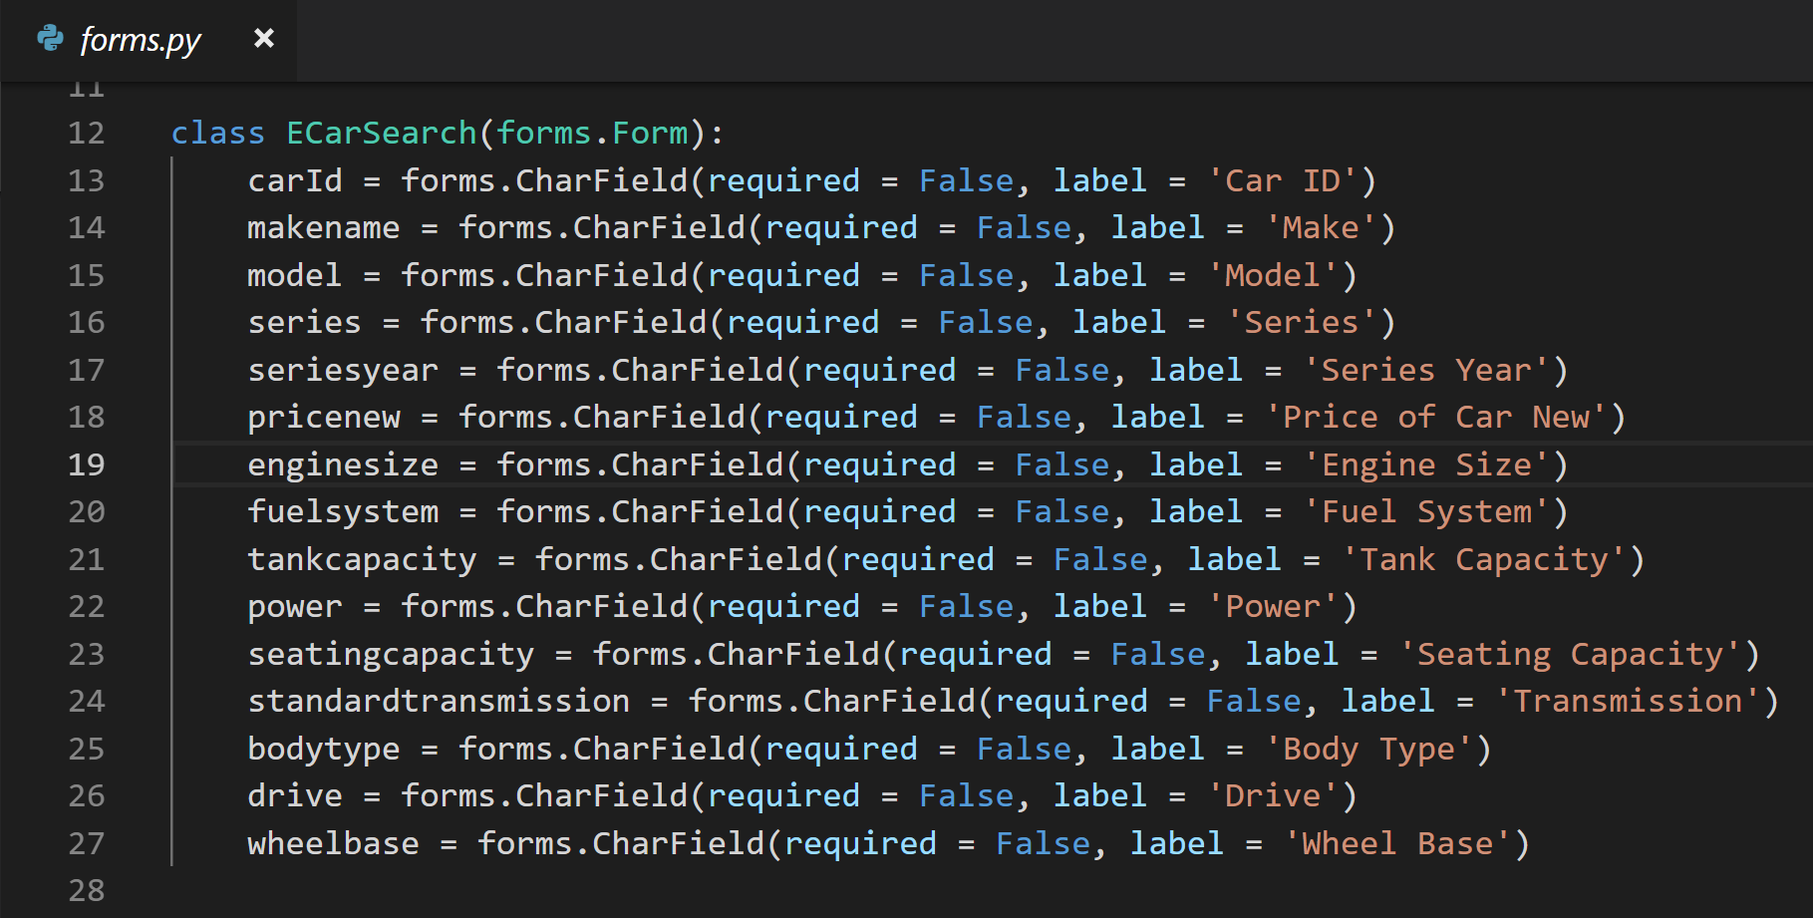**Note:** In regard to the code above, I have chosen not to display all the code (going off the right of the screen). However, all the code is included in the Github (Github/IFB299/Application/CRCProject/CRCApplication).

**Figure 2: Updated query for Search Functionality.**

**Please Note:** All code included above is in the group’s Github, in the application folder. (Github/IFB299/Application/CRCProject/CRCApplication)

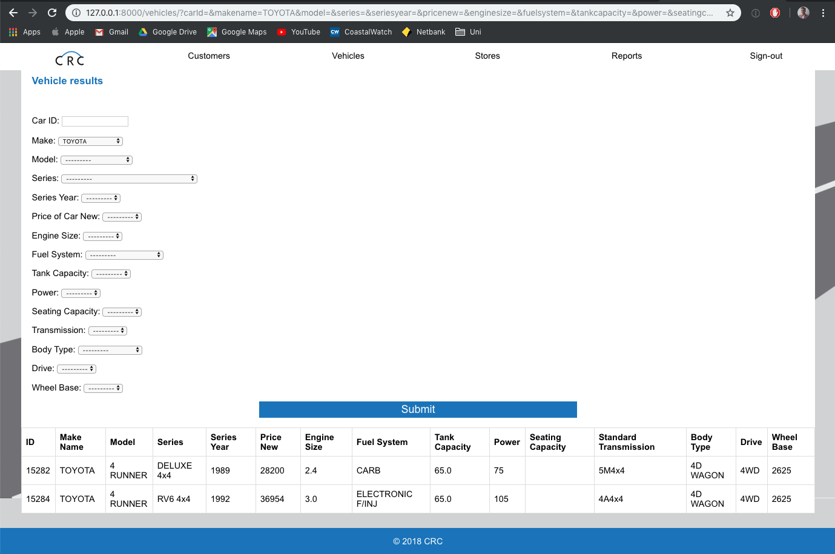

**Figure 3:** Output from the search query.

# **Artefact 4**: Burn Down Chart

Burn down charts are very important for any project as they help the development team to show the client a guideline of the expected time it should take to complete times along with how long it actually takes. This allows the development team to know if the sprint was an overall success, or if they bit off more than they could chew. Which later down the line allows the development team to review their estimated velocity and make changes to it where needed.

This was significantly used in the project as we (the developers) updated the document each day to match the work we had/ hadn’t completed. This then allowed us to prioritize what tasks we needed to get done, and what needed to be changed in our work habits. I believe this was a significant contribution to the project as each week our client wished to review our progress (through the burndown chart) which often lead to a scrum meeting, to discuss what needed to be done and what happened.

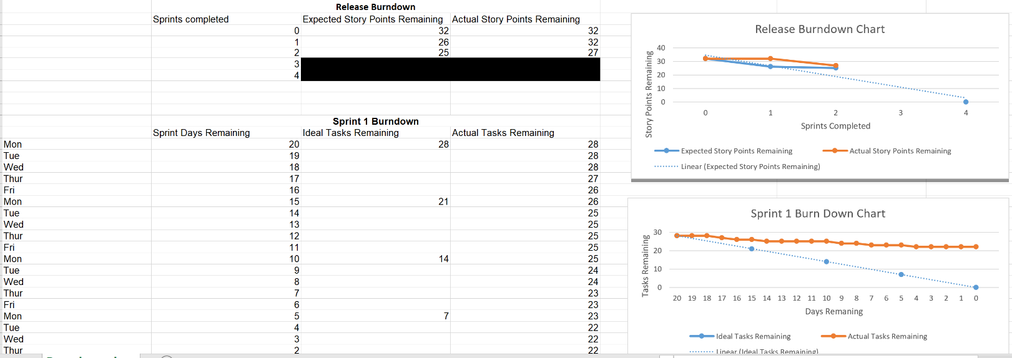

**Figure 1:** Burndown Chart

**Note:** If you wish to see the whole burndown chart please refer to the groups GitHub.

(Github/IFB299/Final Release/[Group 92 Burndown Chart](https://github.com/taylorbindon/IFB299/commit/ff9664e28f87e83b00edf0736cf95b23775c62a8))

# **Artefact 5**: Testing the finalized website to make sure each feature works before showing client final product

Testing is an important part of any project, as it allows you to determine if the overall project works, or where errors occur in the website, which allows for breakpoints to be added so that it can be reviewed and determined how it should be fixed or whether that section should be scrapped and new code can take its place.

This was significantly used throughout the project as testing was done to ensure that all features of the web application worked. This was done when the implementation of functionality was done by various team members, however the final run through was done by the two developers (TJ and I). I believe this is a significant contribution as ensuring the program works before presenting it as a final product to a client is very important.

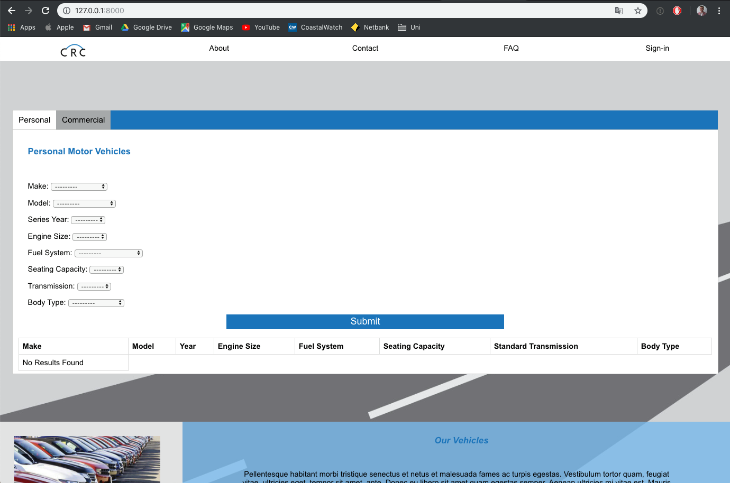

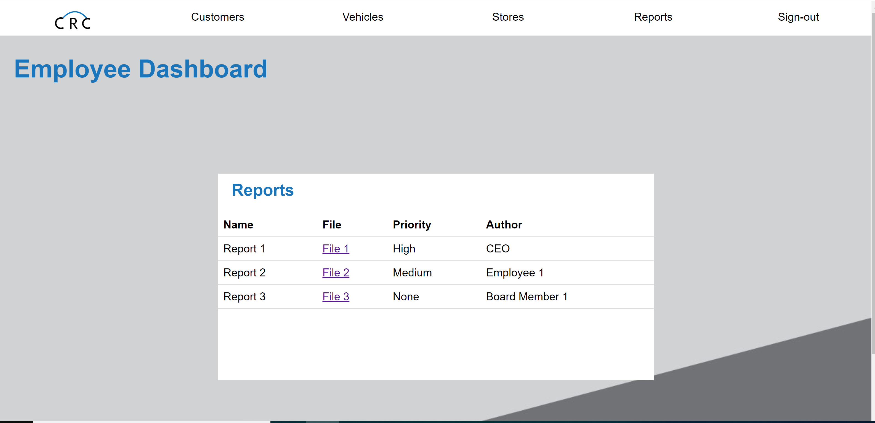

**Figures 1:** Testing overall website.

**Please Note:** This artefact will not be included in the Github as there is no real way to show testing.